# JS Apps Exam – Spotify Single Page Application

Using libraries like **jQuery**, **Handlebars** and **Sammy** is allowed but is not obligatory. You are assigned to implement a **Web application** (SPA) using HTML5, JavaScript, AJAX, REST and JSON with cloud-based backend (Kinvey). The app keeps **users** and **songs**. Users can **register**, **login**, **logout** , view all songs with all the **songs**. They will also be able to **like** the songs added **by other users** and should be able to **listen and remove their own songs**. There should also be a **section** where users can **see only the songs they created**.

## Create a Kinvey REST Service

Register at **Kinvey.com** and create an application to keep your data in the cloud.

Create a collection called **songs**. Each **song** has a **title, artist, imageURL, likes (starting from 0)** and **listened (starting from 0)**.

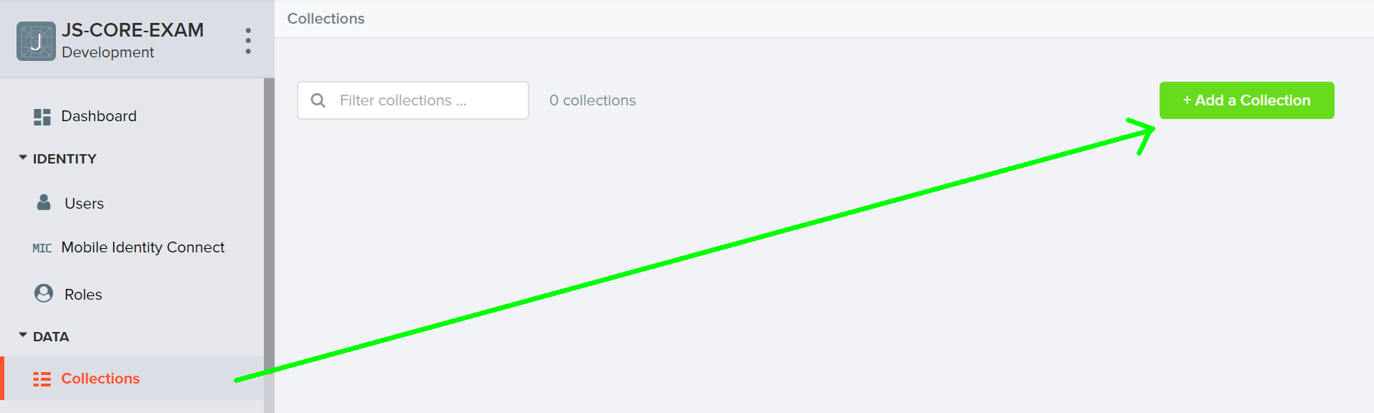

In order to be able to keep track of the **likes and listened** of each song, you need to **allow all users to edit this collection**. So go to the **properties** of the collection:

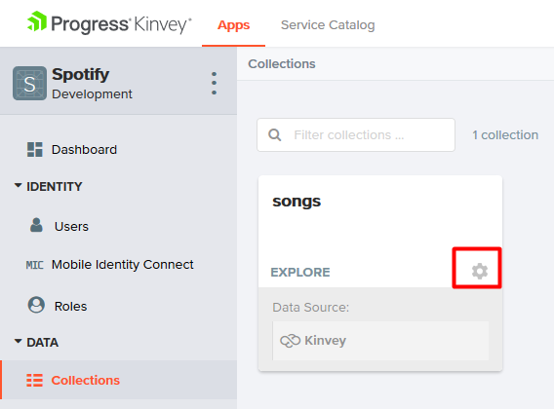

Then go to **permissions** and edit them to look like this:

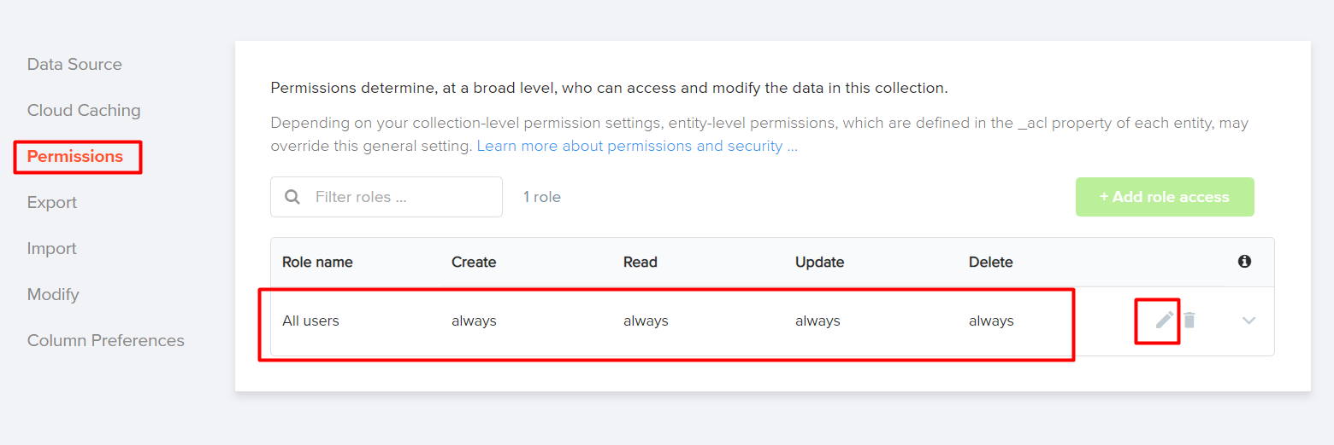

## Test the Kinvey REST Services

Using **Postman** or other HTTP client tool (you can use Kinvey’s built-in **API Console**), test the REST service endpoints:

### User Registration (Sign Up)

|  |  |
| --- | --- |
| **POST** [https://baas.kinvey.com/user/***app_id***/](https://baas.kinvey.com/user/app_id/) | |
| Request headers | Authorization: Basic base64(app_id:app_secret)  Content-Type: application/json |
| Request body | {  "username": "testuser",  "password": "testuserpass890"  } |
| Response  201 Created | {  "_id": "59930c78a743e20c7d3fca77",  "username": "testuser",  "password": "testuserpass890"  } |
| Error response  409 Conflict | { "error": "UserAlreadyExists", "description": "This username is already taken. Please retry your request with a different username", "debug": "" } |
| Error response  401 Unauthorized | { "error": "InvalidCredentials", "description": "Invalid credentials. Please retry your request with correct credentials", "debug": "" } |

The request needs "**Basic**" authentication. Use the Kinvey **App Key** and Kinvey **App Secret** as credentials.

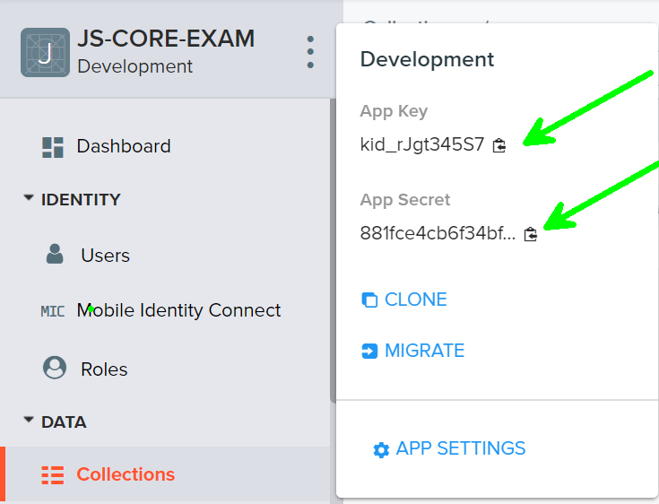

### User Login

|  |  |
| --- | --- |
| **POST** [https://baas.kinvey.com/user/***app_id***/login](https://baas.kinvey.com/user/app_id/login) | |
| Request headers | Authorization: Basic base64(app_id:app_secret)  Content-Type: application/json |
| Request body | {  "username": "testuser",  "password": "testuserpass890"  } |
| Response  200 OK | {  "_id": "59930c78a743e20c7d3fca77",  "username": "testuser"  "_kmd": {  "**authtoken**": "**8e6471bc-3712-4cfb-b92e-50e62a0c80….Duj5fHdM /7XHIe6KdY=**"  …  },  …  } |
| Error response  401 Unauthorized | { "error": "InvalidCredentials", "description": "Invalid credentials. Please retry your request with correct credentials", "debug": "" } |

Successful login returns an "**authtoken**" which is later used to authenticate the CRUD operations.

### User Logout

|  |  |
| --- | --- |
| **POST** [https://baas.kinvey.com/user/***app_id***/_logout](https://baas.kinvey.com/user/app_id/_logout) | |
| Request headers | Authorization: Kinvey **authtoken** |
| Response  204 No Content |  |
| Error response  401 Unauthorized | { "error": "InvalidCredentials", "description": "Invalid credentials. Please retry your request with correct credentials", "debug": "" } |

To logout, you need to provide the "**authtoken**" given by login / register as "**Kinvey**" authorization header.

### List all Songs

|  |  |
| --- | --- |
| **GET** [https://baas.kinvey.com/appdata/***app_id***/songs](https://baas.kinvey.com/appdata/app_id/songs)?query={}&sort={} | |
| Request headers | Authorization: Kinvey authtoken |
| Response  200 OK | [{  "title":"Better",  "artist":"Khalid",  "imageURL":"https://i.ytimg.com/vi/KkOF8UiB7u8/maxresdefault.jpg",  "likes":"0",  "listened":"3",  "_acl":  {  "creator":"5bfd4674682ae23931b4f91c"  },  "_kmd":  {  "lmt":"2018-11-28T15:25:24.521Z",  "ect":"2018-11-28T14:55:00.958Z"  }  }, …] |
| Error response  401 Unauthorized | { "error": "InvalidCredentials", "description": "Invalid credentials. Please retry your request with correct credentials", "debug": "" } |

### Create Song

|  |  |
| --- | --- |
| **POST** [https://baas.kinvey.com/appdata/***app_id***/songs](https://baas.kinvey.com/appdata/app_id/songs) | |
| Request headers | Authorization: Kinvey authtoken  Content-Type: application/json |
| Request body | {  "title": "Better",  "artist": "Khalid",  "imageURL": "https://i.ytimg.com/vi/KkOF8UiB7u8/maxresdefault.jpg",  "likes": 0,  "listened": 0  } |
| Response  201 Created | {  "title": "Better",  "artist": "Khalid",  "imageURL": "https://i.ytimg.com/vi/KkOF8UiB7u8/maxresdefault.jpg",  "likes": 0,  "listened": 0,  "_acl": {  "creator": "5bfd4674682ae23931b4f91c"  },  "_kmd": {  "lmt": "2018-11-28T15:39:58.801Z",  "ect": "2018-11-28T15:39:58.801Z"  },  "_id": "5bfeb6ce682ae23931bf7d26"  } |
| Error response  401 Unauthorized | { "error": "InvalidCredentials", "description": "Invalid credentials. Please retry your request with correct credentials", "debug": "" } |

### Like Song

|  |  |
| --- | --- |
| **PUT** [https://baas.kinvey.com/appdata/***app_id***/songs/***song_id***](https://baas.kinvey.com/appdata/app_id/songs/song_id) | |
| Request headers | Authorization: Kinvey authtoken  Content-Type: application/json |
| Request body | {  "title": "Better",  "artist": "Khalid",  "imageURL": "https://i.ytimg.com/vi/KkOF8UiB7u8/maxresdefault.jpg",  "likes": 1,  "listened": 0  } |
| Response  200 Ok | {  "title": "Better",  "artist": "Khalid",  "imageURL": "https://i.ytimg.com/vi/KkOF8UiB7u8/maxresdefault.jpg",  "likes": 1,  "listened": 0,  "_id": "5bfeb6ce682ae23931bf7d26",  "_acl": {  "creator": "5bfd4674682ae23931b4f91c"  },  "_kmd": {  "lmt": "2018-11-28T15:45:13.760Z",  "ect": "2018-11-28T15:39:58.801Z"  }  } |
| Error response  401 Unauthorized | { "error": "InvalidCredentials", "description": "Invalid credentials. Please retry your request with correct credentials", "debug": "" } |

### Listen Song

|  |  |
| --- | --- |
| **PUT** [https://baas.kinvey.com/appdata/***app_id***/songs/***song_id***](https://baas.kinvey.com/appdata/app_id/songs/song_id) | |
| Request headers | Authorization: Kinvey authtoken  Content-Type: application/json |
| Request body | {  "title": "Better",  "artist": "Khalid",  "imageURL": "https://i.ytimg.com/vi/KkOF8UiB7u8/maxresdefault.jpg",  "likes": 1,  "listened": 1  } |
| Response  200 Ok | {  "title": "Better",  "artist": "Khalid",  "imageURL": "https://i.ytimg.com/vi/KkOF8UiB7u8/maxresdefault.jpg",  "likes": 1,  "listened": 1,  "_id": "5bfeb6ce682ae23931bf7d26",  "_acl": {  "creator": "5bfd4674682ae23931b4f91c"  },  "_kmd": {  "lmt": "2018-11-28T15:45:13.760Z",  "ect": "2018-11-28T15:39:58.801Z"  }  } |
| Error response  401 Unauthorized | { "error": "InvalidCredentials", "description": "Invalid credentials. Please retry your request with correct credentials", "debug": "" } |

### My Songs

|  |  |
| --- | --- |
| **GET** [https://baas.kinvey.com/appdata/***app_id***/songs?query={"_acl.creator":"${***user_id***}"}](https://baas.kinvey.com/appdata/app_id/songs?query=%7b%22_acl.creator%22:%22$%7buser_id%7d%22%7d) | |
| Request headers | Authorization: Kinvey authtoken |
| Response  200 OK | [  {  "_id": "5bfeb6ce682ae23931bf7d26",  "title": "Better",  "artist": "Khalid",  "imageURL": "https://i.ytimg.com/vi/KkOF8UiB7u8/maxresdefault.jpg",  "likes": 2,  "_acl": {  "creator": "5bfd4674682ae23931b4f91c"  },  "_kmd": {  "lmt": "2018-11-28T16:10:15.621Z",  "ect": "2018-11-28T15:39:58.801Z"  }  },…  ] |
| Error response  401 Unauthorized | { "error": "InvalidCredentials", "description": "Invalid credentials. Please retry your request with correct credentials", "debug": "" } |

## Spotify – HTML and CSS

You аre given the Web design of the application as **HTML** + **CSS** files.

* Initially all views and forms are shown by the HTML. Your application may **hide** by CSS (display: none) or **delete** from the DOM all unneeded elements or just display the views it needs to display.
* You may render the views / forms / components with **jQuery** or **Handlebars**.

**Important**: don’t change the elements’ **class name** and **id**. Don’t rename form fields / link names / ids. You are **allowed** to add **data attributes** to any elements. You may modify **href attributes** of links and add **action/method attributes** to forms, to allow the use of a routing library.

## Spotify Client-Side Web Application

**Design** and **implement** a client-side front-end app (SPA) for managing **songs**. Implement the functionality described below.

### Notifications (5 pts)

The application should notify the users about the result of their actions.

* In case of successful action an **informational (green) notification message** should be shown, which disappears automatically after 3 seconds or manually when the user clicks it.



* In case of **error**, an **error notification message** (red) should be shown which disappears on user click.



* During the AJAX calls a **loading notification message (blue)** should be shown. It should disappear automatically as soon as the AJAX call is completed.



* **NOTE: You get all 5 point if the notifications contain the right message**

### NavBar (5 pts)

Implement a **NavBar** for the app: navigation links should correctly change the current screen (view).

* Clicking on the links in the **NavBar** should display the view behind the link (views are sections in the HTML code).
* Your application may **hide** by CSS (display: none) or **delete** from the DOM all unneeded elements or just display the views it needs to display.
* The given „**Home,** **All Songs, My Songs, Welcome and logout**" should be visible **only** for logged in users.



* Anonymous users can **only** view the **login and register**.



### Home Screen (10 pts)

The initial screen should display the register, login and the initial image + footer.



### Register User (10 pts)

By given **username** and **password** the app should register a new user in the system.

* You should make the following validations:
  + The **username** should be **at least 3 characters** long
  + The **password** should be **at least 6 characters** long
* After a **successful registration**, a notification message **"User registration successful."** should be displayed and the **home page should be displayed again but with the right navbar**.
* In case of **error** (eg. invalid username/password), an appropriate error **message** should be displayed and the user should be able to **try** to register again.
* Keep the user session data in the browser’s **session storage**.
* You should be able to go from the **"register"** page to the **"login"** page

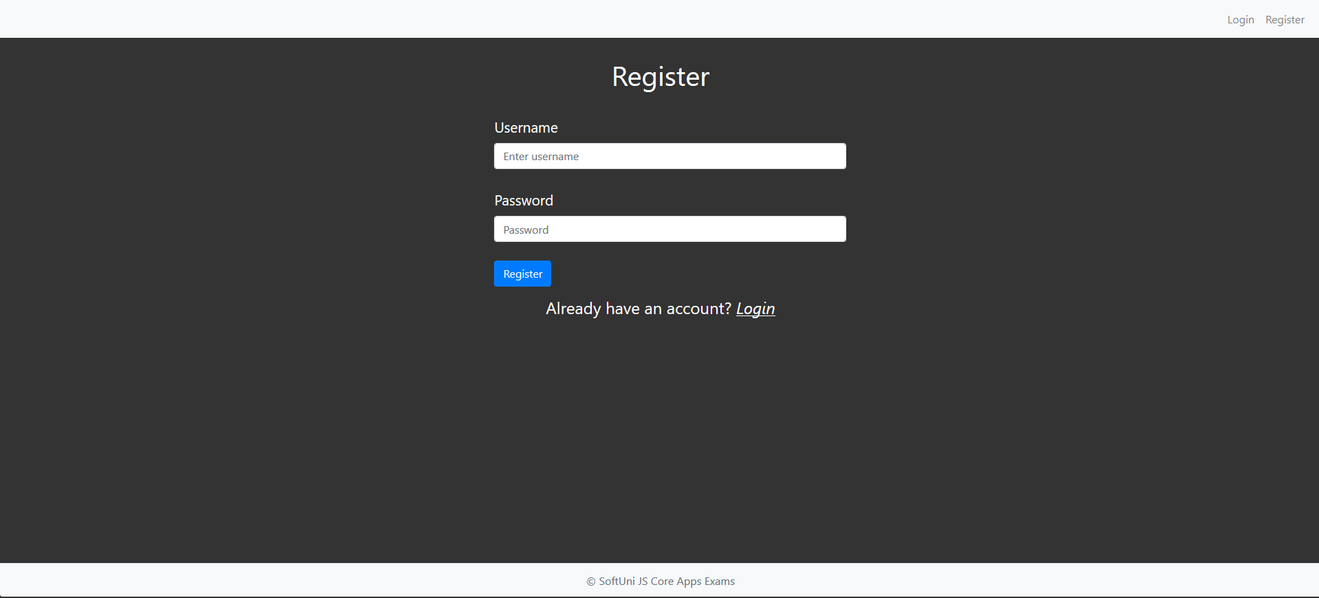

### Login User (5 pts)

By given **username** and **password** the app should be able to login an existing user.

* After a **successful login**, a notification message **"Login successful."** should be displayed and the user home screen should be displayed.
* In case of **error**, an appropriate error message should be displayed and the user should be able to fill the login form again.
* Keep the user session data in the browser’s **session storage**.
* Clear **all** input fields after **successful** login.
* You should be able to go from the **"login"** to the **"register"** page

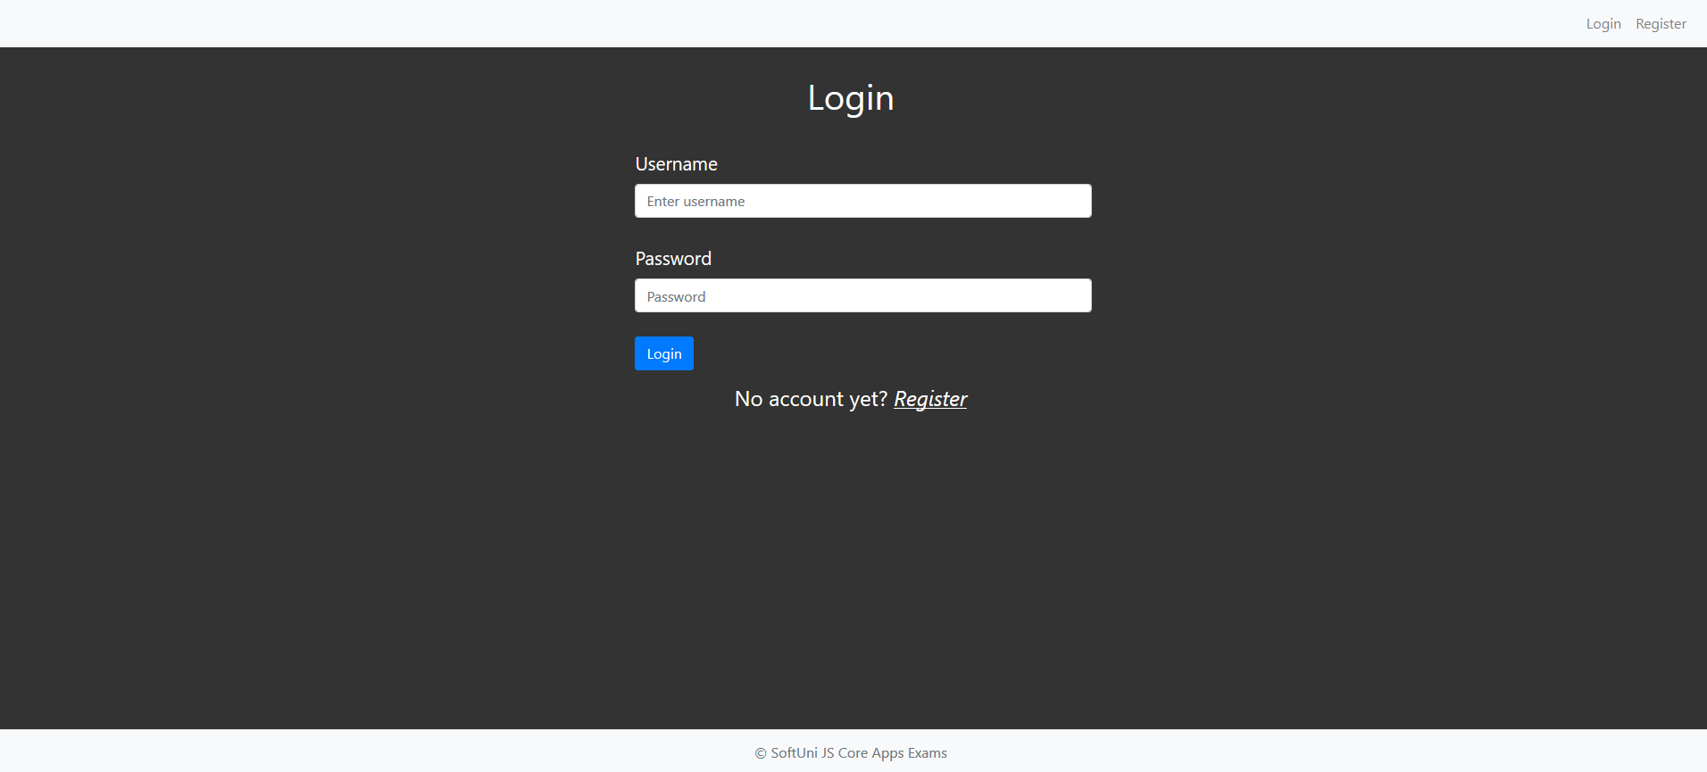

### Logout (5 pts)

Successfully logged in user should be able to **logout** from the app.

* After a **successful** logout, a **notification** message **"Logout successful."** should be displayed.
* After successful logout, the **Sign In screen** should be shown.
* The **"logout" REST service** at the back-end should be obligatory called at logout.
* All local information in the browser (**user session data**) about the current user should be deleted.

### Logged In All Songs (25 pts)

Successfully logged users should be welcomed by the **home screen**. They should also be able to see the **"all songs" view**, which must have the following:

* The **songs** should be listed in the **format** as shown in the Web design (see the screenshot below).
* The songs must be sorted as follows:
  + First come the songs that are **not** created by the current user, **sorted by likes in descending**
  + Then come the songs that **are from the current user** sorted **by likes in descending** then by **"listened" count in descending**
* Each **song** has **title**, **image,** **artist**, **likes, listened counter**.
* There are two possibilities for the songs
  + The song was created by the current user:

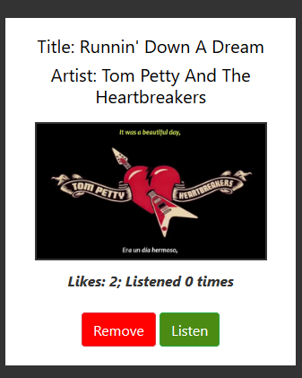

* + The song was **not** created by the current user:

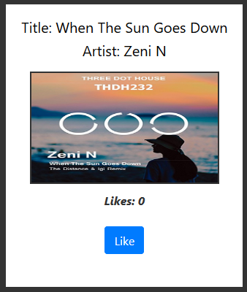

* The **"all songs"** view should look like this:

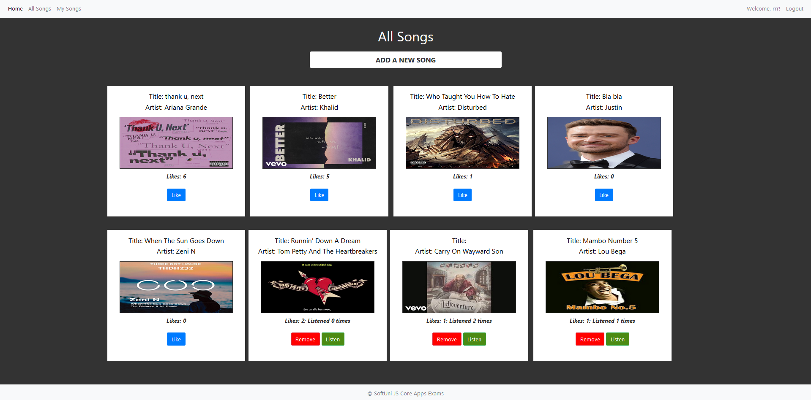

### Add Song Screen (10 pts)

Logged in users can **add** songs. Clicking the **[Add a new song]** link should open a form.

* You should make some validations:
  + The title should be **at least 6 characters** long
  + The artist should be **at least 3 characters** long
  + The image should start with **"http://"** or **"https://"**
* After a **successful** song creation, a notification message **"Song created successfully."** should be displayed and the **all songs page** should be shown.
* The **inputs** in the form **should be cleared**

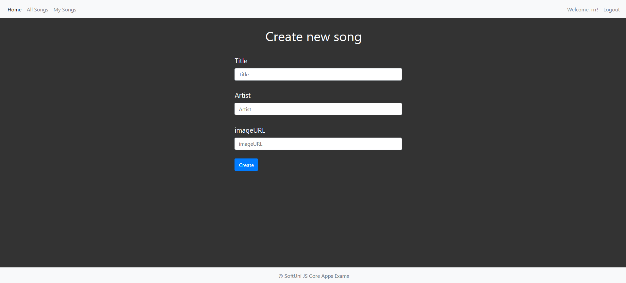

### Like a Song (5 pts)

Users **should** be able to **like** songs that are **not** theirs. Clicking the [**Like**] link on each song should **increase the likes** of the particular song. Each user can **like a song unlimited times.**

* After a **successful** song update, a notification message **"Liked!"** should be displayed.

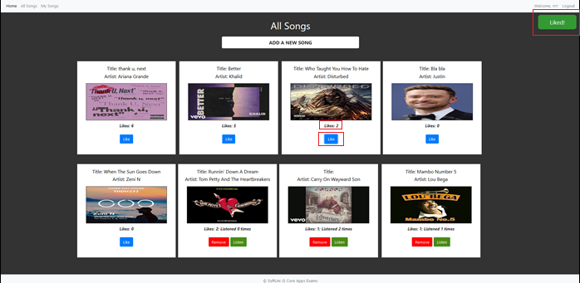

### Listen a Song (5 pts)

Users **should** be able to **listen** songs that are theirs. Clicking the [**Listen**] link on each song should **increase the listen counter** of the particular song. A user can **listen his songs unlimited amount of times**

* After a **successful** song update, a notification message **"You just listened {songName}"** should be displayed.

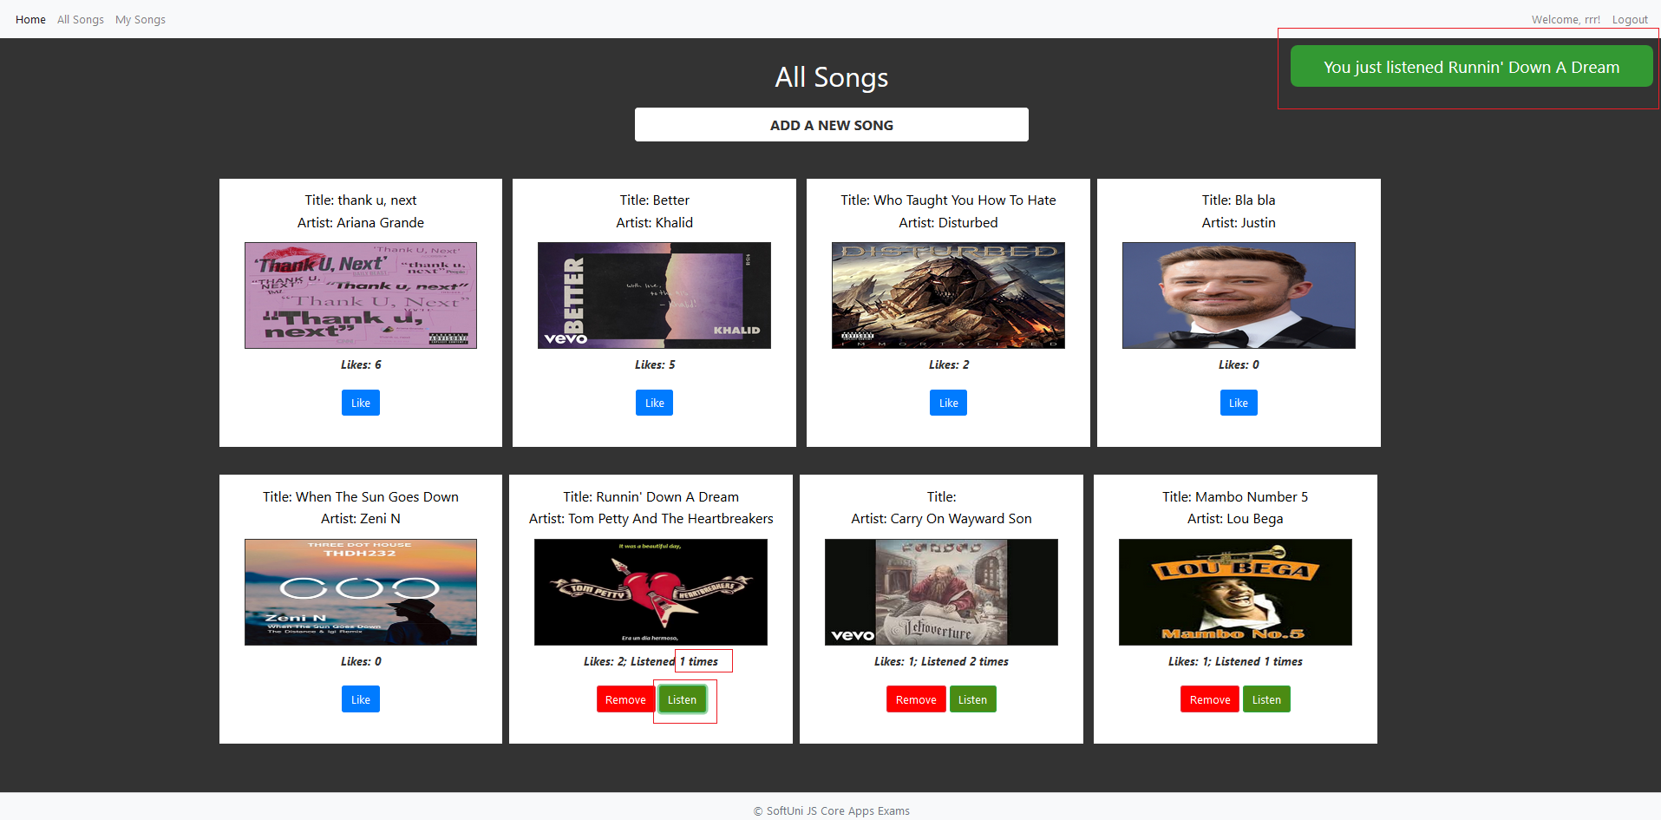

### Delete Song (5 pts)

Song creators **should** be able to **delete** their **own** songs by clicking the [**Remove**] button.

* After **successful** pet delete a notification message **"Song removed successfully!"** should be displayed and the **all songs view** should be **shown**.

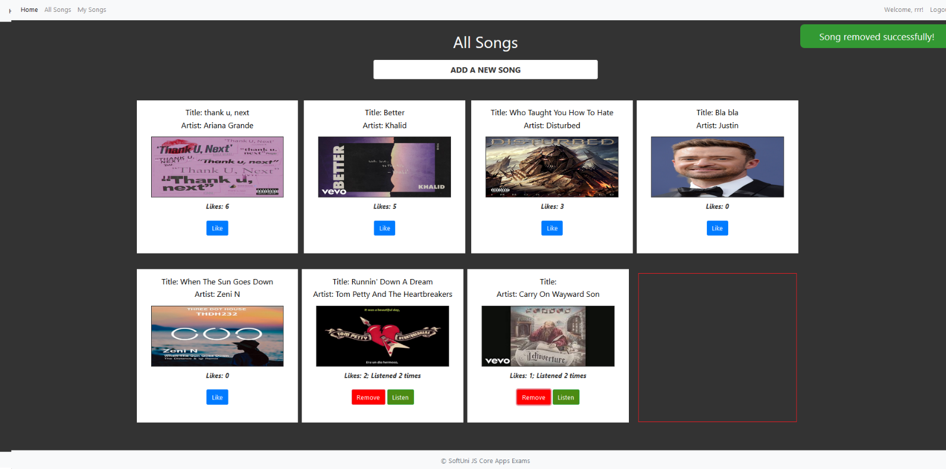

* Deleting works immediately, with **no confirmation**.

### My Songs (10 pts)

Each **user** should be able to view his own songs by clicking [**My Songs**].

* The **songs** should be listed like in the **all songs** section, except theuser should see only the songs that he created.
* The songs should be **ordered** first by the amount of **likes in descending**, then by the **"listened" counter in descending**

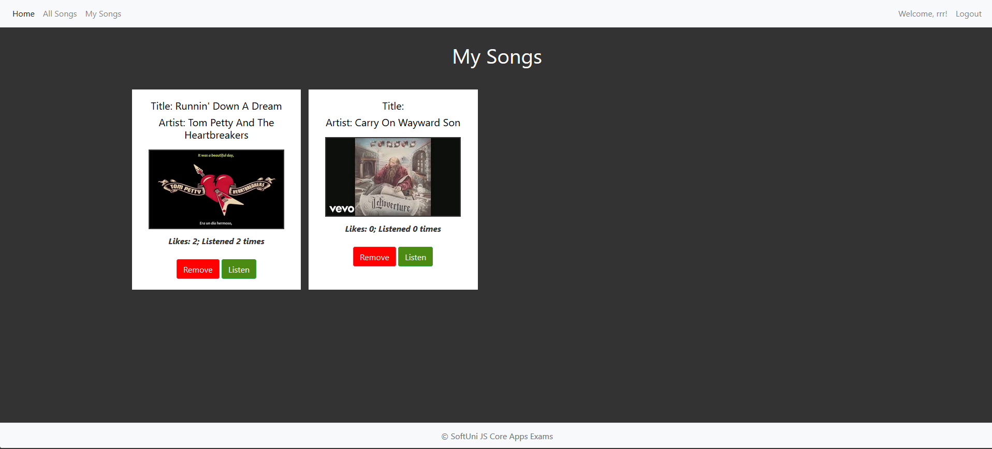

## Submitting Your Solution

Place in a ZIP file your project folder. Exclude the node_modules folder. Upload the archive to the Judge.